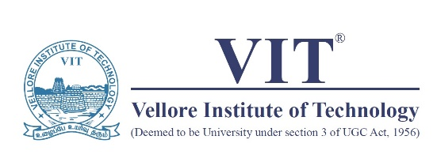

Report on Career Opportunities

**Name of the Student:** Ashima Fatima

**Registration Number:** 21BAI1830

**Programme:** Bachelor of Technology in Computer Science and Engineering with Specialisation in Artificial Intelligence and Machine Learning

**School:** School of Computer Science and Engineering

**Learnings from the webinar “Career Opportunitites” held on 18.9.2021 from 11AM to 12.30PM**

The Business of Information Technology

The difference between the previous pandemics and now is that businesses that would have been erased are thriving due to the incorporation of technology. IT and business are concepts that have become so inextricably interwoven that they cannot be separated anymore. In this sense, we can think of IT as a platform that brings businesses closer to the customer.

EXMAPLES OF FIELDS EXISTING IN THE TECH INDUSTRY:

* IT – software, devices and infrastructure, business services, telecom services, emerging tech
* Software Products – web and mobile apps, infrastructure software, enterprise software (software big businesses use)
* Engg and R&D – embedded engineering, VLSI, Product LC Management, R&D Services
* Project Oriented Services – consulting, system integration, testing services, infrastructure services
* IT Outsourcing – application, infrastructure, data center, security, cloud management
* Training & support – hardware & software deployment, IT education & training
  + technology changes at an extremely rapid pace and so there is a need for a system to be in place to ensure that both the general public and the emerging and existing workforce are aware and educated in them so as to be able to make full use of emergent technology.
* iTeS & BPO – process management services, KPO Services, Customer Interaction services
* Emerging Tech – AI/robotics/AV/VR, IoT, data analytics, social software,
* Devices & Hardware – hardware products, device design & Mfg

*How are projects handed out and processed in the industry?*

* MARKET DOMAIN LED VERTICALS - Banking, life sciences, retail, manufacturing
  + The existence of these domains is the reason why IT is able to exist at the scale it does today
* TECHNOLOGY LED HORIZONTALS - SAP, Analytics, testing, BPO, Infra
  + These are groups that specialise in a certain field of technology
* SUPPORT FUNCTIONS - Quality, Finance, Marketing, Admin, Staffing
  + Additional sectors that are also necessary to run a company

Projects are at the intersection of the horizontals and verticals and may spread over a variety of them.

TYPICAL CAREER PATH OF AN IT GRADUATE:

*Format: job description (example job title/s) [written in chronological order]*

trainee (programmer analyst) - developer (quality analyst) - tech lead (project lead) - project manager(technical architect) - delivery manager (enterprise architect) - group head (client partner, principal architect)

YOU AS A GRADUATE:

Every year, plenty of job roles become obsolete and new jobs take their stead. In this cut throat sector, you need to make yourself marketable and in order for that you need to improve the following skills:-

* **Technical ability** – continual learning, certifications, diverse technologies, analytical thinking
  + Important to have depth in a few skills but be aware of other tech and skills too
* **Communication**
* **Teamwork** – collaborate and don’t compete, eagerness to assist colleagues
  + The IT industry has teamwork at its absolute core
* **Leadership** – responsibility, confidence, communication
* **Attitude** – curiosity, discipline, enthusiasm to take on new work
* **Productivity** – plan your work, deliver on-time, attention to details, errors and mistakes free

*How to choose what to learn and what to pass on when there is so much available?*

Decide according to two criteria – passion and necessity

*Further look into: the organised and unorganised sector in IT*